Host a static website using S3
(Lovepreet Kaur)
1.Search S3 in the spotlight search and then click on S3 once the option is visible.
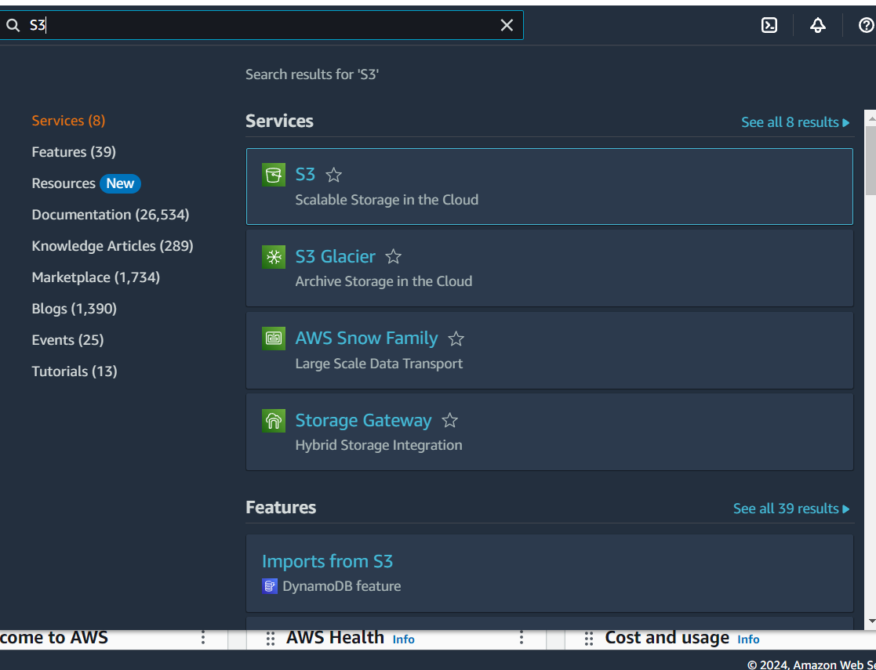
2. Click on create bucket.
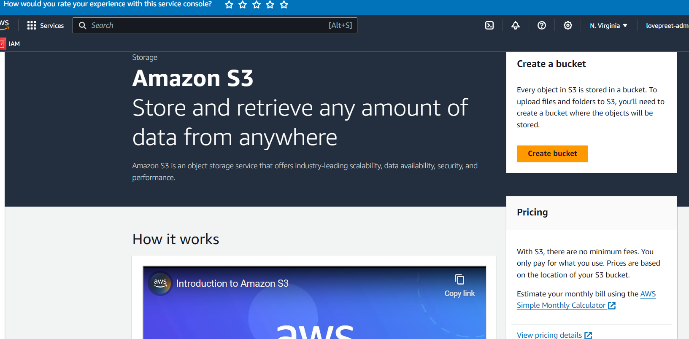
3. Select bucket type as a general purpose and give it a unique name. it will give you an error message if the name is already taken.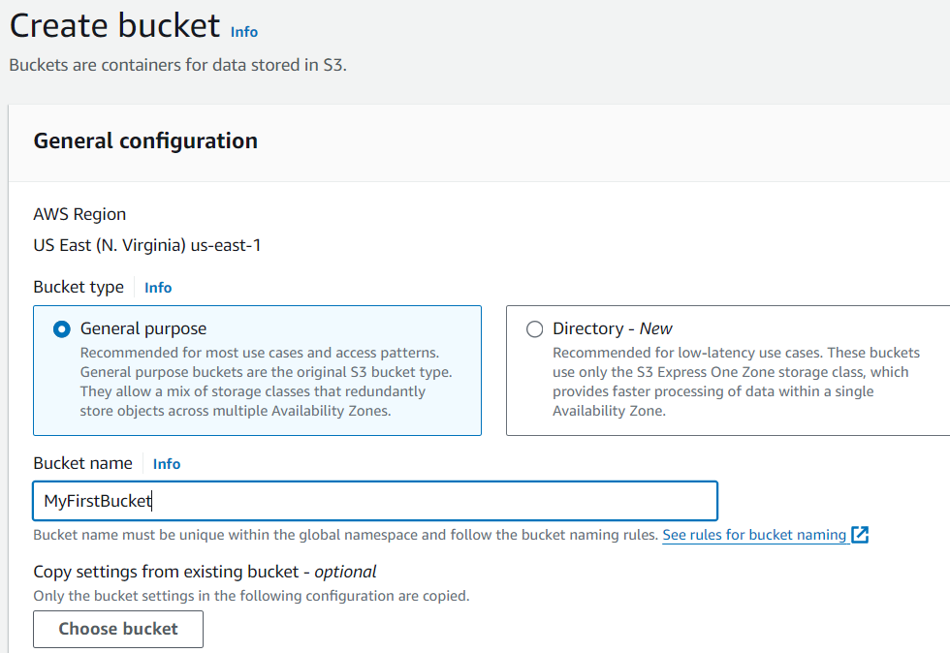

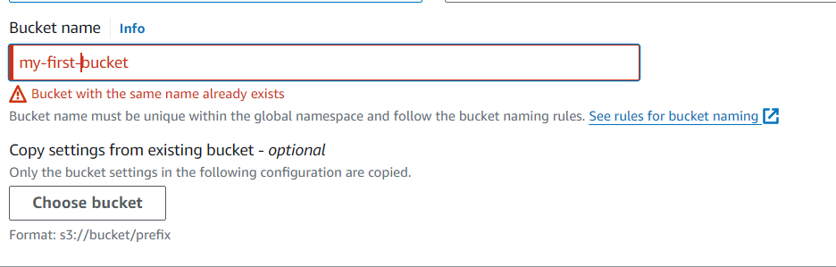

4.Enable network Access Control lists enable to give access to the AWS network to access this website publicly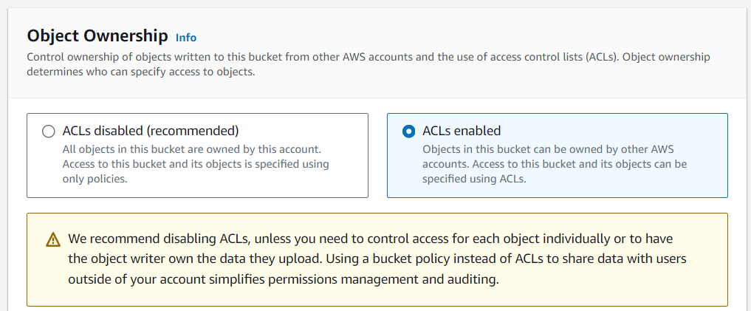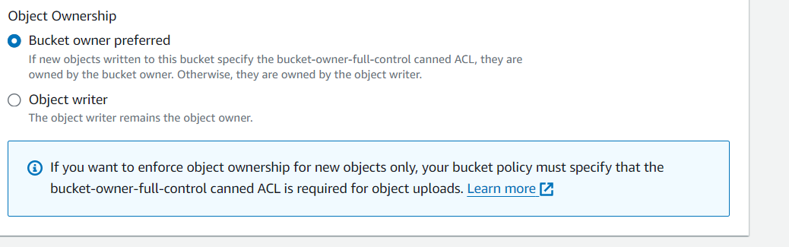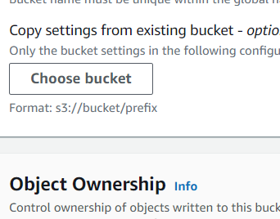

5. Uncheck the block so that website can be accessed publicly.
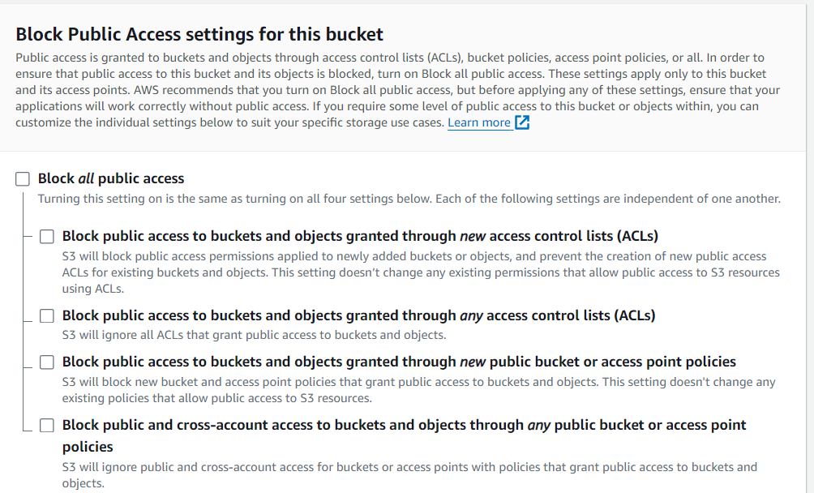
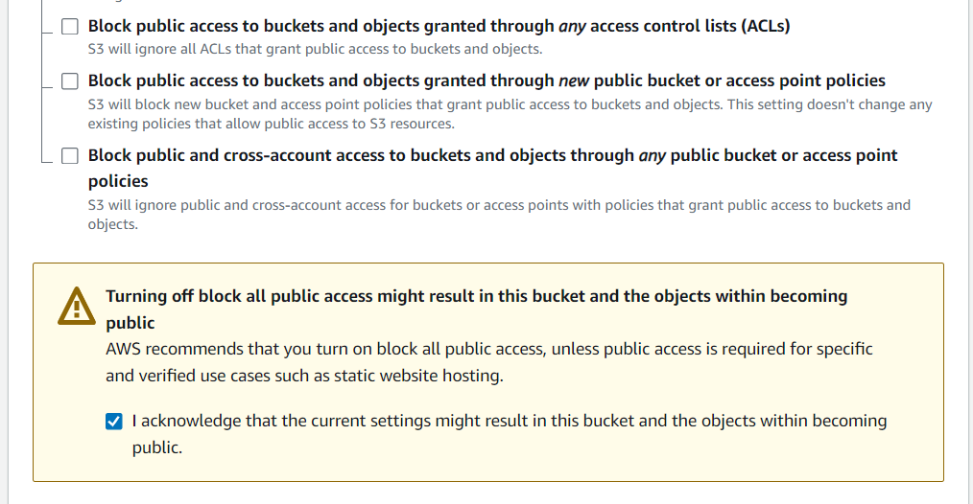

6. click on create bucket. For now, leave other settings as it is. 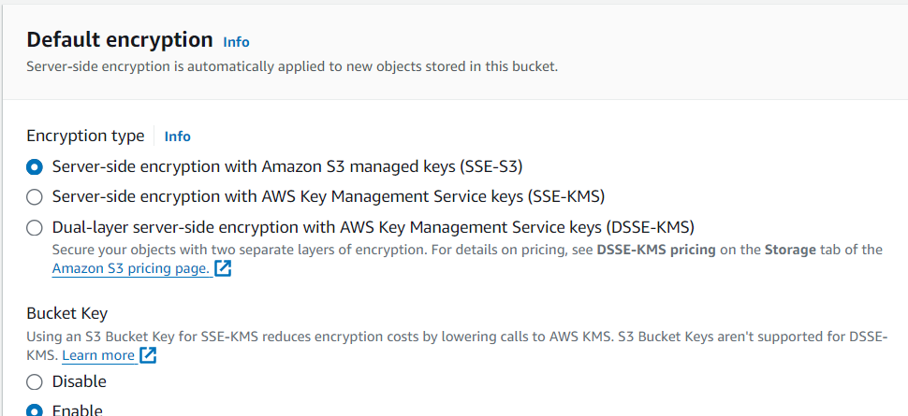
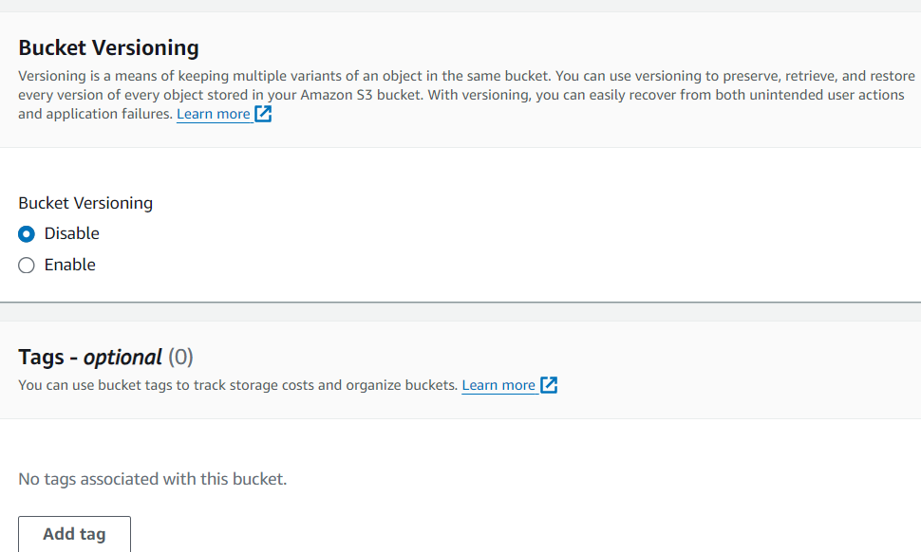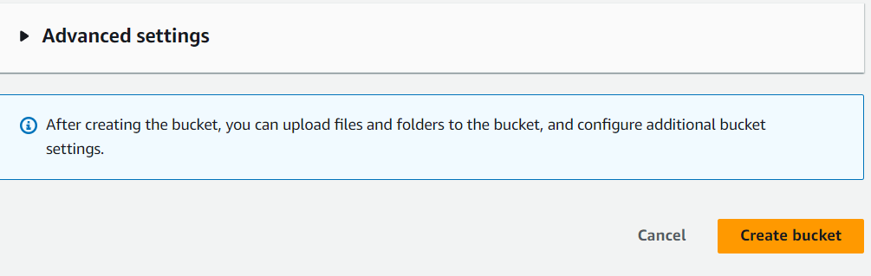

7. Bucket has been created.
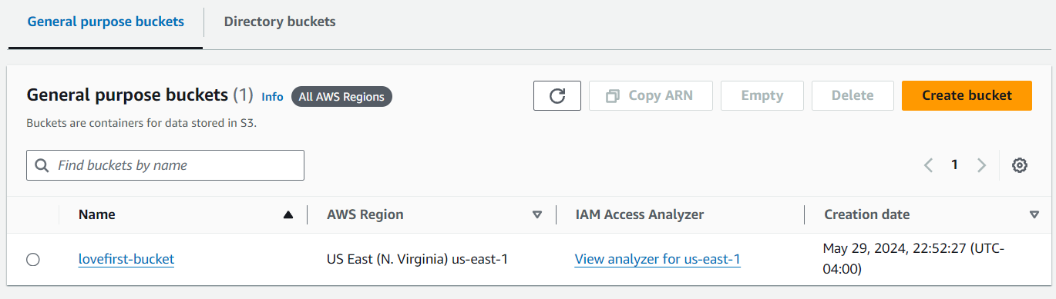

8. Upload files in the bucket.
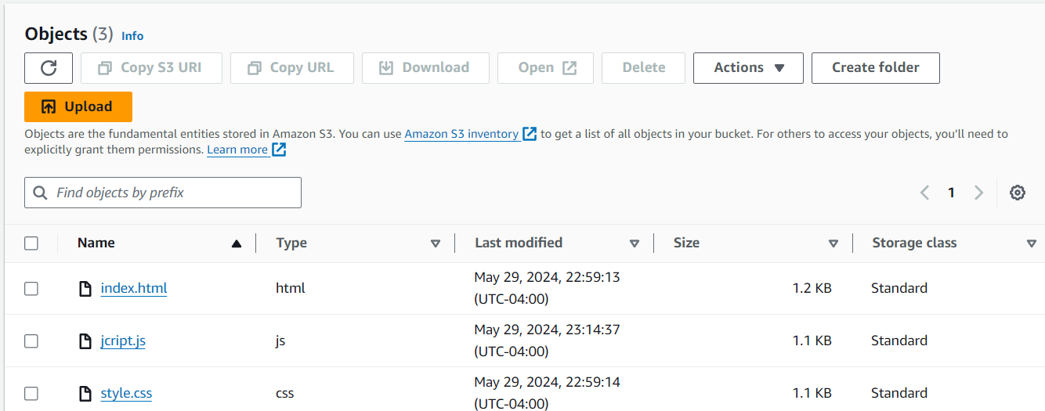

9. Make files publicly Accessible. 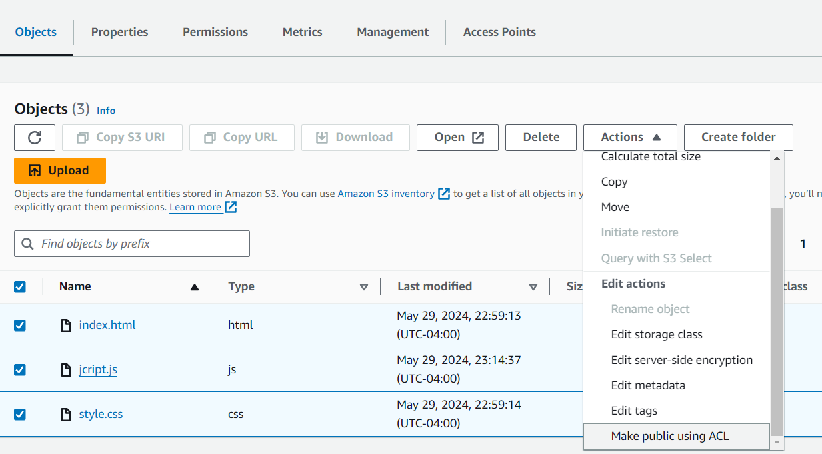

8.Go to permissions and enable static website.
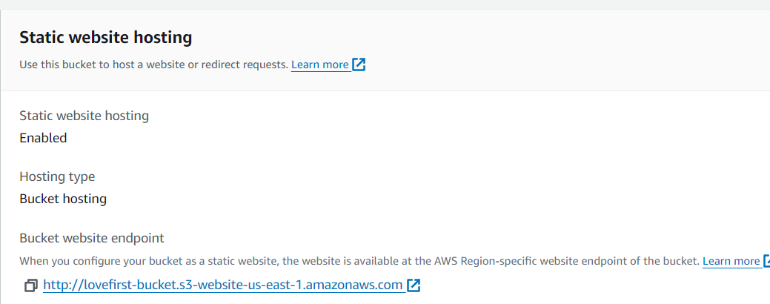

9. Click on the website URL to Access it
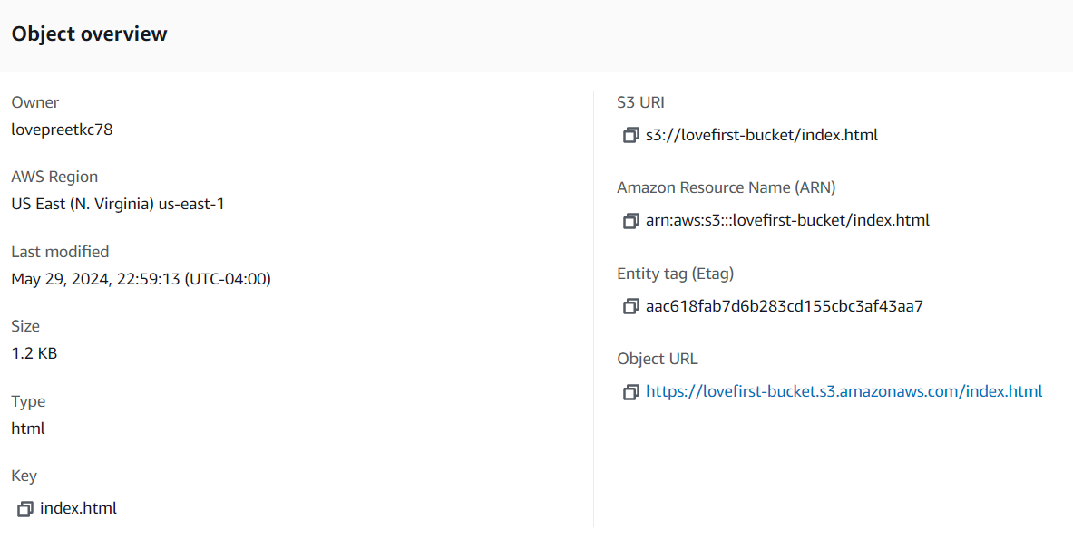Website :: 